

CSE471 : System Analysis and Design
Lab Assignment on Figma

Project Title : Education Aid Disbursement System
Group Number : 03

Submitted by : Naved Abrar Nibir
Student ID : 22201025
Section: 03

Date :30/10/2026

Instruction:
- You have to design the interfaces of any two of your assigned features [according to the submitted requirement analysis] of your project using Figma. All members should work on the same project.
- The designed interfaces can not be duplicated among group members.
- Common interfaces like login form, sign up form, forget password, profile management page must be avoided.
- You can check out this manual: Lab 03 : Figma Manual.docx
- Sample figma file link:
https://www.figma.com/design/yiKMQ4K5v3LF3DMYGbd1SS/Figma-basics?node-id=601-11&t=3xuNTZJ4iouU77qL-1
Sample Prototype link:
https://www.figma.com/proto/yiKMQ4K5v3LF3DMYGbd1SS/Figma-basics?node-id=601-11&t=3xuNTZJ4iouU77qL-1

Feature- 01: Describe the feature [According to the submitted requirement analysis]

Add Figma Screenshots Here related to feature-01

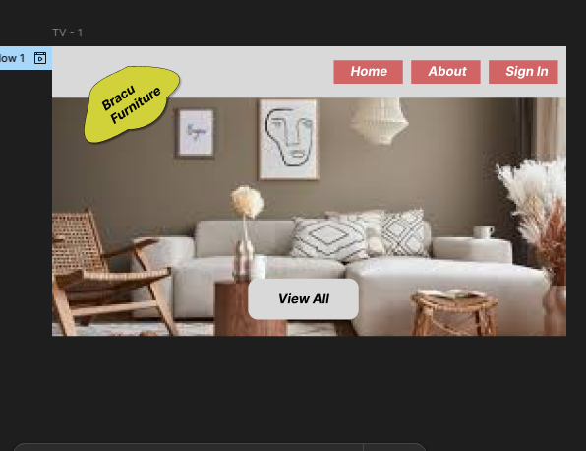
Feature- 02: Describe the feature [According to the submitted requirement analysis]

Add Figma Screenshots Here related to feature-02

Figma File Link
Add the link of your project figma file (Use share option)
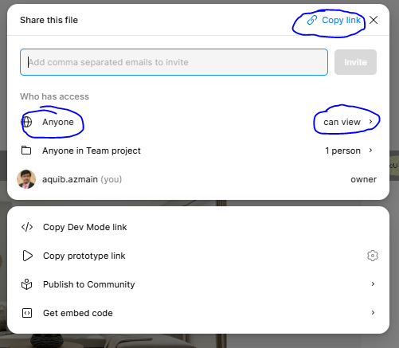
https://www.figma.com/design/PKlGDIyM8jSBx5KEJGkbll/Untitled?node-id=3-35&t=ZqV4HU1Iyl8bsxzi-1

Prototype Link
Add the link of your sigma prototype (Use share option)
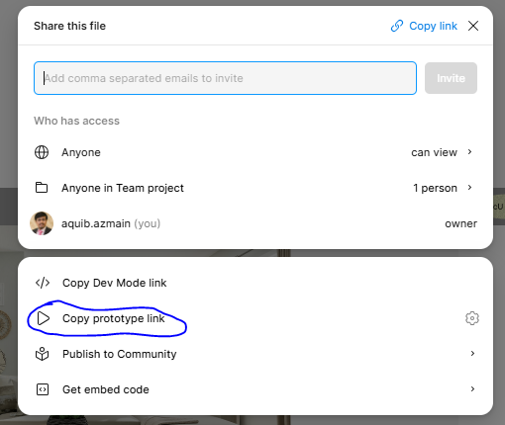

https://www.figma.com/proto/PKlGDIyM8jSBx5KEJGkbll/Untitled?node-id=3-35&t=ZqV4HU1Iyl8bsxzi-1

